**Assignment 4 - Hands on Session**

**Bhuvanesh P - MM19B027**

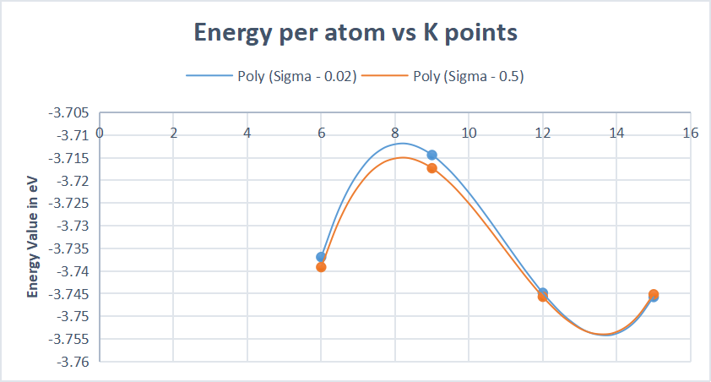

The plot of K points vs energy for sigma values of 0.5 and 0.02 is plotted above

The energy difference between k-points is shown below.

|  |  |  |
| --- | --- | --- |
|  | Sigma - 0.02 | Sigma - 0.5 |
| 6 - 9 | 0.02251832 | 0.02182832 |
| 9 -12 | -0.03041885 | -0.02837137 |
| 1. 15 | -0.00091352 | 0.00054424 |

As the k points increased, the energy values plateaued. The difference between 12 and 15 is less than 1 milli eV so we can choose 12 K points for our computation.

